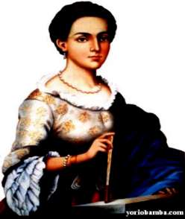
UNIDAD EDUCATIVA “ISABEL GODIN”
NOMBRE: MARIELA GUZMAN
CURSO: 3 “B” CONTABILIDAD
PROFESOR:Lic rosita Fernández
TRABAJO:
REGLAS CON EL MUST
2014-2015

HOMEWORK
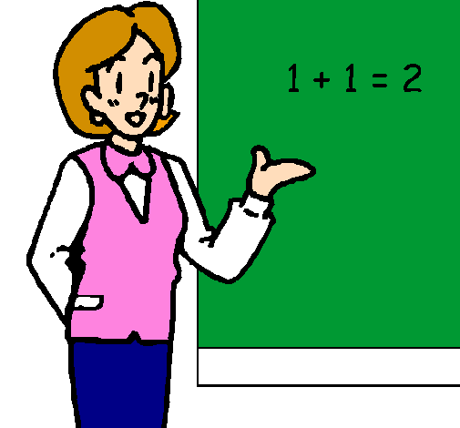
1.- She must be a Teacher.

2.-He must be a doctor
3.- I must read this bock

4.- ) I must go to SCHOOL
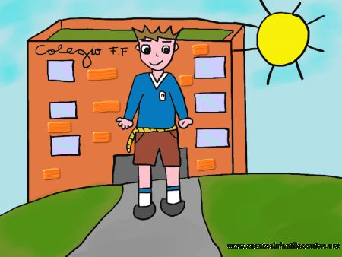

5.- I must get some rest
6.- You must have a passport to travel abroad.

7.- You must tidy your room
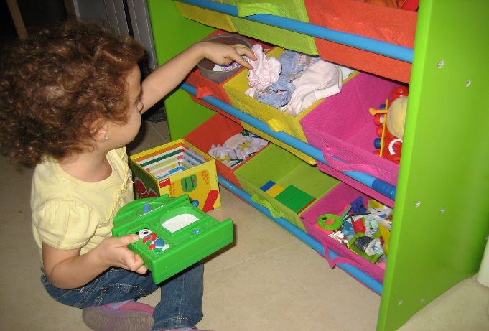
8.- You mustn´t be late.
9.- she must savarse hands before eating
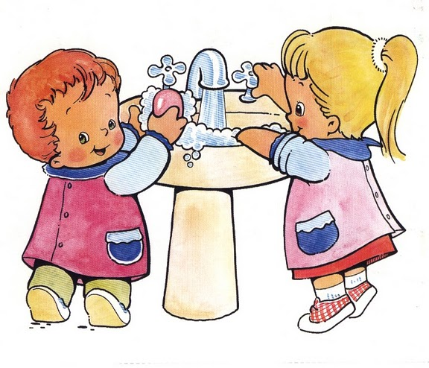
10.- he must leave in the afternoon with her friends

